DQ-30 Top Drive Head

**Operating Instruction**

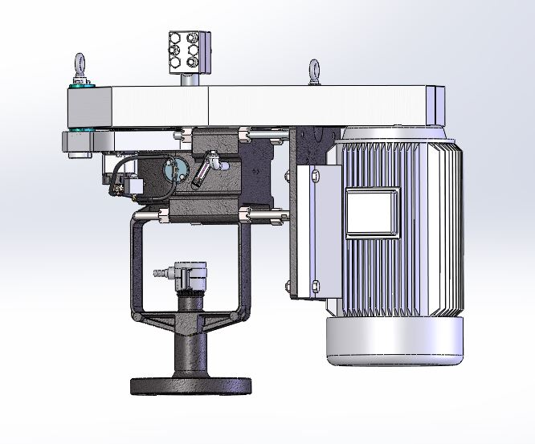

2017-08-20

**catalogue**

1. Introduction

1.1 Overview

1.2 Top-drive performance

1.3 Top-drive features

1.4 Introduction to the top drive

1.4-1, hydraulic box assembly

1.4-2, the motor plate assembly

1.4-3 base frame and belt cover

1.4-4 Seal

2. Installation

2.1 Distribution of the top drive

2.2 Hoisting of the top drive

2.3 Motor assembly of the top drive

2.4 Selection and installation of belts

2.5 Assembly seal (root box)

2.6 Assemble the top drive and the disk root box

2.7 Assemble the pumping rod clamp

3. Operation

3.1 Start the inspection

3.2 Start

3.3 Reverse control

3.4 Stop and dismantling procedures

4. Maintenance and lubrication

4.1 Routine

4.2, lubricating oil

4.3 Maintenance of seal (root box)

5. Reference data

5.1 Calculation formula

5.2 Maintenance and troubleshooting

5.3 Maintenance and service log

6. Drawing catalogue

View 1.4-1 Top drive assembly

View 1.4-2 Hydraulic box assembly

View 1.4-3 Motor frame assembly

View 1.4-4 Seal (root box) assembly

View 2.7-1 Gripper installation

View 3.3-1 Schematic diagram of the hydraulic brake system

**Installation, operation, and maintenance**

**1. Introduction**

**1.1. Overview**

This is a light top driving force designed for domestic users according to years of foreign experience and users. The top drive has four following functions:

1. Dynamic seal of wellhead rotation

2, support rod, and well fluid loading

3. Safe release of reversal energy when shutdown

4. Provide a method of driving (provide a method of rotating the pump)

Based on these four functions, we embody the following intentions in our design objectives:

1, to provide an economic pump transfer method

2. Safe support for the axial load of the pump transport system

3. Safety to mediate the energy consumption during braking

4. Provide a durable and effective dynamic seal

**1.2., Top-drive function**

|  |  |
| --- | --- |
| Effective light rod size | 1¼ in |
| Dynamic radial rated load of axial thrust bearing (25,000 hrs @ 500 rpm) | 60.9 kN (13,700 lbf ) |
| Light-dry gripper capability | 111 kN (25,000 lbf ) |
| Maximum allowable light rod maximum torque | 1085 N ⋅m (800 ft ⋅lbf ) |
| Maximum allowable motor power | 22.4 kW (30 HP) |
| Maximum light bar rotation degree | 600 rpm |
| Minimum light rod rotation *** | 224 rpm (5V); 180 rpm (B);413 rpm (C) |
| Maximum allowable static structural load | 58.9 kN (13,300 lbf ) |
| Maximum outer diameter of the passive wheel | 23.60 in (5V); 25.35 in (B);24.40 in (C) |
| Hydraulic oil requirements | HVI 68, 4.5 liters (1.2 US gal) |
| The weight of the machine | 272 kg (600 lbs) |
| The whole height | 1.00 m (39.5 in) |
| The diameter of the moving axle | 2¼ in |

*** Minimum light rod speed

Reflect 5HP, 1200 rmp motor, 5V belt for passive wheel 23.6 "(600mm), 4.4" (112mm), or B for passive wheel 25 "(635mm) 3.4" (86.36mm) or 24 "(610mm), C for active wheel 8" (203mm). **According to the characteristics of domestic PC pump, under the maximum light rod allowable torque and the maximum passive wheel diameter, different speed requirements can be the best motor power matching. Avoid the phenomenon of large horse-pulled car through frequency conversion and speed regulation, and achieve the best economy and reliability.**

**warn**

In many top-tier driver applications, the torque available on the drive can exceed the torsional performance of other system components (such as pumping rod strings). Most top drives are not equipped with a torque turn-off system, so the user needs to have a good understanding of the instantaneous torque possibilities for a given drive system. In the reference section, the formula for calculating this value is given. Assuming in a very short time, the motor is likely to generate 150% rated horsepower. For reference, the 1 "stage" D " pumping rod has a rated torque of 1300 Nm (960 ft force)

**warn**

Unless otherwise specified, this top drive passive pulley is manufactured in cast iron HT 200 with a maximum allowable linear speed of 2000 m / min. When a passive wheel of 25 " (635mm) reaches a linear speed of 2000 m per minute, the rotation speed is 1000rpm. Generally, the maximum recoil speed of the top drive is less than 600rpm.

The minimum light rod speed specified in these guidelines is determined by the deceleration ratio and physical size of the pulley. The specified maximum light rod speed includes a safety factor to guarantee the maximum allowable value.

The oil specified in the table indicates the type of oil, which is suitable for the environment throughout the year

A hydraulic oil with sufficient viscosity index is recommended to maintain its use in an environment of annual atmospheric limits. The maximum viscosity at the beginning absolutely does not exceed 5000 SUS, and the maximum operating temperature is determined by the temperature resistance of the shaft seal of the hydraulic pump, 80℃ (176 ℉). The hydraulic oil is replaced every 12 months.

The choice of belts and belt wheels, with respect to this question will be given in Section 2.4.

**1.3 Characteristics of the top drive**

The top drive has the following characteristics:

It is convenient to install oneself

Safe reversal torque release

Excellent sealing performance

Vacation low cost maintenance

**Easy to install**

Balancing lifting and installation of two lifting ring bolts

The jack behind the motor board can easily adjust the belt tension

The belt hood is linked by a hinge and is extremely easy to install and use

**Safe reversal torque release**

The hydraulic system provides a set of effective mechanical braking power

The brake oil pump is directly linked to the main shaft with a synchronous pulley

Adjust the brake power through the safety valve

**1.4 Top-drive instruction manual**

The top drive can be broken down into four systems / components (see view 1.4-1)

1. Hydraulic box assembly

2. Motor board assembly

3. Foundation support structure and belt cover assembly

3.1 Hoisting structure assembly of the hydraulic system

3.2 Hydraulic pump and synchronous belt system

3.3 Belt cover assembly

4. Seal assembly (root box)

|  |  |  |  |
| --- | --- | --- | --- |
| 10 | 40003 | any power-generating or power-driven machine | 1 |
| 9 | 40002 | Motor mounting board | 1 |
| 8 | 10004 | Light rod gripper | 1 |
| 7 | 10003 | pulley cover | 1 |
| 6 | 10002 | ring | 2 |
| 5 | 10001 | Synchronous belt system | 1 |
| 4 | 20002 | hydraulic pump | 1 |
| 3 | 20001 | bearing housing | 1 |
| 2 | 30003 | The root of the box | 1 |
| 1 | 30001 | Pack root box base | 1 |
| order number | figure number | name | quantity |

|  |
| --- |
| **View of the 1.4-1**  **Top drive final assembly map** |

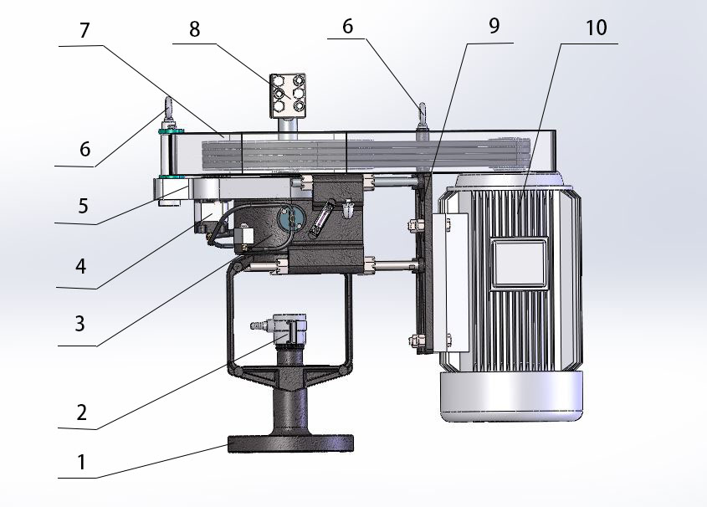

**1.4-1, hydraulic box assembly (View 1.4-2)**

The top-drive hydraulic box part has three main functions:

1. Support the total shaft load of the screw pump system

2. Control the reverse energy release

3. Provide a way to drive the downhole pump

|  |  |  |  |
| --- | --- | --- | --- |
| 11 | 10004 | Light rod gripper | 1 |
| 10 | 20010 | Bearing box cover | 1 |
| 9 | 20003 | lip seal | 1 |
| 8 | 20003 | lip seal | 1 |
| 7 | 20009 | tapered roller bearing | 1 |
| 6 | 20008 | brake block | 1 |
| 5 | 20007 | Brake hub | 1 |
| 4 | 20006 | live axle | 1 |
| 3 | 20005 | plunger | 1 |
| 2 | 20004 | tapered roller bearing | 1 |
| 1 | 20003 | lip seal | 1 |
| order number | figure number | name | quantity |
|  | | | |

|  |
| --- |
| **View # 1.4-2**  **Hydraulic box assembly** |

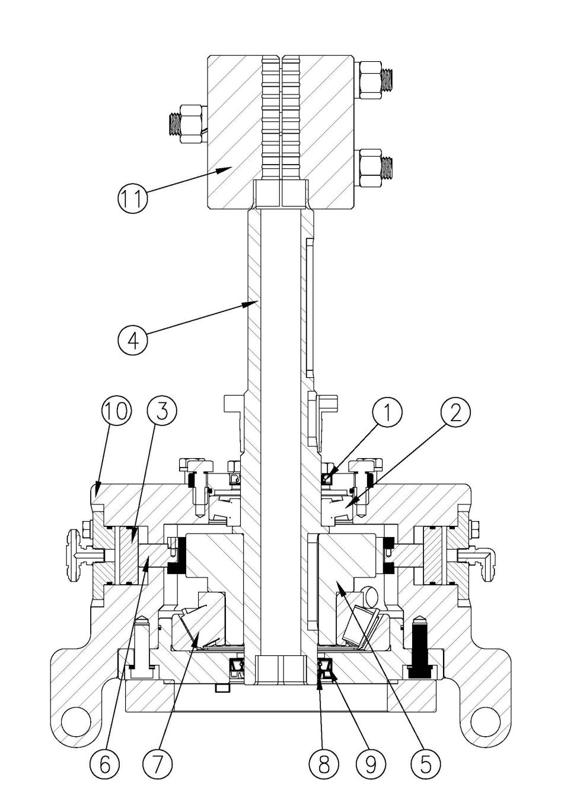

With hydraulic pressure, the weight of the column. Polishing rod clamp, load rating of 111 kN (25000 lb). The dynamic load of the conical roller bearing must be rated large enough to support the weight of the post and the fluid load in the well. The dynamic load rating for the axial bearings at the top drive is 60.9 kN (13,700 lb), based on 25000 hours (approximately 3 years running life), 500 rpm. The upper radial bearing of the hydraulic housing is a cylindrical roller bearing that absorbs the radial loads from the drive pulley. To determine a dynamic load level, except for the nameplate rating, refer to Section 5 of the conversion formula (Reference Data).

The speed of driving the reverse rotation (due to the energy release stored in the well) is mechanically controlled. In the backspin mode, the hydraulic pump presses the hydraulic oil to push the piston out of the brake pad, causing resistance to the brake pad mounted on the spindle sleeve to achieve the spindle deceleration.

The light rod holder (see Figure 1.4-2) is the driving connection between the light rod and the main shaft. Once attached to the light rod, the clamp is on the hollow drive shaft. When the hollow shaft rotates, the gripper holds the light rod and rotates together with the hollow shaft (spindle).

The hydraulic box assembly consists of two circulating systems connected to a high-pressure hose on a hydraulic pump. The hydraulic pump is also running as the spindle rotates. Although the spindle is rotated clockwise (from the top), the hydraulic oil is circulated freely, with a single relief valve opens. When the spindle is rotated counterclockwise, the single safety valve is closed, and the hydraulic pump pushes the brake pad to brake to reduce the shaft speed. The system has good performance, low cost and easy maintenance.

The hydraulic tank requires 4.5 liters (1.2 gallons, 1 liter with auxiliary tank) for normal operation (see Section 4 Service, Oil type and frequency conversion requirements). Fill or replenish tank oil from the 90, ½ " NPT connector. At the same time, the ¾ " NPT plug at the bottom is used to discharge the hydraulic box fluid and remove the garbage in the box, and the moving parts in the protection box are running normally.

**1.4-2, Motor plate assembly (see view 1.4-3)**

The motor board assembly consists of one motor support and four screw sliding needle shafts.

|  |
| --- |
| **View of the 1.4-3** |

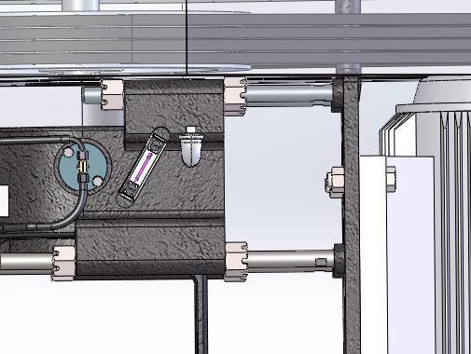

As shown in the figure, the four nuts on the right side tighten the belt, and the left side four nuts lock the screw sliding needle shaft.

The motor bracket is designed to accept up to 30 horsepower. There are four screw slip needle shaft support or guide, sliding into the hydraulic box, make the motor shaft parallel to the light rod.

weld a nut at the bottom of the motor plate to push the motor base and adjust the levelness of the two pulleys.

**1.4-3 Foundation support structure (rack) and belt cover assembly**

As mentioned above, the basic support structure and belt protection assembly consists of the following three parts: hydraulic system mounting plate and lifting structure, hydraulic pump and synchronous belt system, belt cover assembly

Hydraulic system installation and lifting structure

Hydraulic system installation and lifting structure. The hydraulic parts are mounted on the surface of the hydraulic tank and fixed, and the synchronous belt system is installed on the top of the hydraulic housing. The system not only serves as a synchronous belt cover and a fixed hydraulic pump, but also provides a lifting point on the outside, which forms a balanced lifting structure together with the top lifting point of the motor board. At the same time, install the belt cover column here, and support the installation of the belt cover.

Hydraulic pump and synchronous belt system

The assembly includes hydraulic pumps, synchronous strap and pulley with corresponding liners. The purpose of this system is to connect the hydraulic pump directly to the spindle.

Belt cover assembly

The belt protection of the top drive consists of two separate sections, both opened from their own pivot points. This makes the power transmission system (belts, belts and buings) easy to operate. The physical height of the belt shield is a space of up to 4 belts (configuration B, C or 5V).

1.4-4 Seal unit assembly (root box)

|  |  |  |  |
| --- | --- | --- | --- |
| 11 | 30011 | The PTFE sealing ring | 1 |
| 10 | 30010 | Pressure tight cap | 1 |
| 9 | 30009 | The plate root box presses the block | 1 |
| 8 | 30001 | Pack root box base | 1 |
| 7 | 30008 | The PTeflon gasket | 1 |
| 6 | 30007 | Upper bronze seal assembly | 1 |
| 5 | 30006 | Graphite disc root | 5 |
| 4 | 30005 | The PTFE sealing ring | 1 |
| 3 | 30004 | Lower bronze seal assembly | 1 |
| 2 | 30003 | lip seal | 2 |
| 1 | 30002 | Panroot box bushing | 1 |
| order number | figure number | name | quantity |

|  |
| --- |
| **View # 1.4-4**  **Seal unit assembly** |

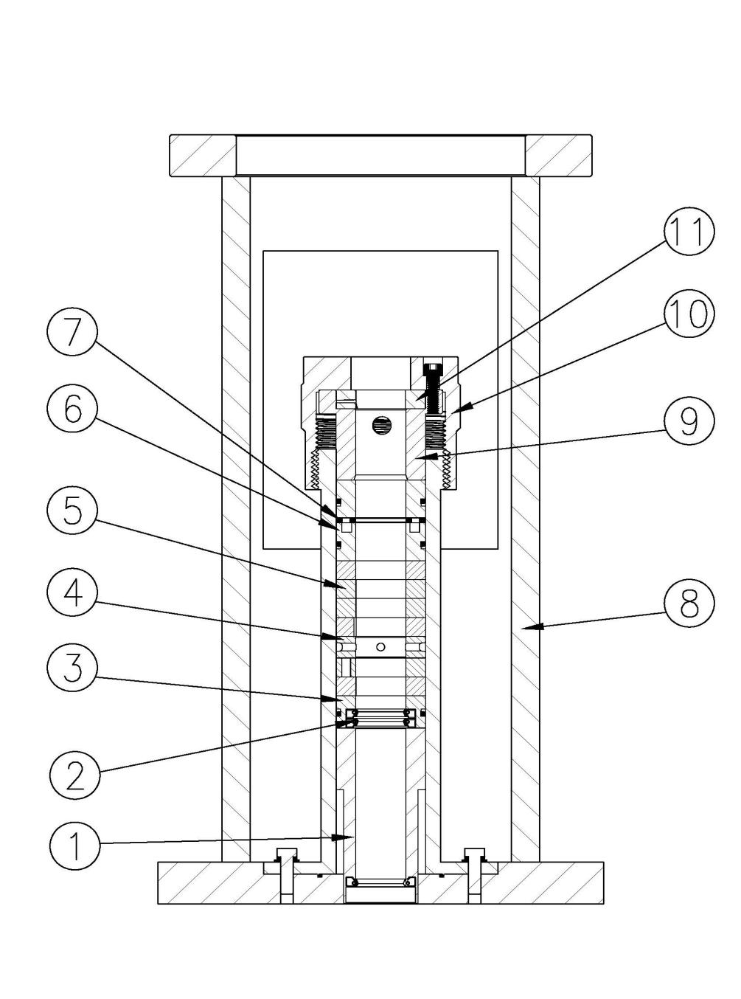

The drive sealing unit uses a light rod surface for dynamic sealing; it is equipped with a standard economic kit, using the traditional solid cord packaging. An optional environment kit can be added with a connector installed on the press cap nut.

The sealing unit always becomes the same round as the frame structure, built-in root box. The base frame is provided with the hydraulic box, base and hydraulic box are separable for maintenance.

The following table describes the types of fillers (woven rope) used in the sealing device

|  |  |  |  |
| --- | --- | --- | --- |
| Light pole size | The root of the species | sectional dimension | number of turns |
| 1-1/4" | Solid graphite | 1 / 2 " Fang | 7 |
| Teflon | 1 / 2 " Fang | 1 (inside the pressure cap) |

Environmental protection toolbox

Detachable leakage containers can be combined with the sealing device. The hose in the container is connected to the joint located on the packaging cap, and if the package is not sealed, the oil flows out.

The main objectives of the sealing device (including environmental kits) are:

• independent operation

It is convenient to adjust oneself

Vacation site maintenance

Avoid well-site contamination

independent operation

As mentioned, one of the functions of this top drive is to provide a dynamic sealing mechanism to maintain wellhead pressure. The sealing unit of the top drive can perform the task without the help of the other components. Therefore, the remaining upper parts of the top drive can be installed or removed for repair without interfering with the pressure contained in the well.

Convenient adjustment

Each well has different operating conditions —— The adjustable sealing unit cap allows for proper compression (when applied to packaging). The rotating (tightening) sealing cap can easily compress the packing for the purpose of sealing.

Site maintenance

Forked rope filler can make it extremely convenient to replace. The maintenance convenience of this change is obvious, and it takes about 20 minutes to maintain a well. Usually, it is also a person's job.

Avoid pollution in the well site

When all dynamic seals leak, the operator wants to know if it has spread before the leak, the goal is to control the overflow of the seal itself. The container of the environmental kit does this because the leaking oil flows into the container unless you haven't done field maintenance for a long time or the container is damaged.

**2. Installation**

**2.1 Transportation and protection of the top drive**

Each drive is packed in a wooden box and can be handled with a forklift truck. The top drive is divided into a sealing unit and a hydraulic housing because the portion of the sealing unit is usually installed on the wellhead as a separate project. During the unit shipment, the light rod clip is also included in the same box.

**2.2 Lifting**

With a long sling and three unloading clips, attach one end of the sling to the ring bolt mounted on the motor mounting frame and the other end to the rod of the hydraulic mounting frame and lifting structure."Block" the sling on the hook. The balance point will depend on whether you have an electric motor installed and, if so, the counterweight size and the weight of the motor match.

**2.3 Install the motor to the top drive device**

The motor bracket with pre-cut grooves and holes accommodate motor frame sizes from 213T to 326T (5HP to 25HP, 900 rpm motor; 5HP to 30HP, 1200 rpm, motor or 7.5 HP to 30HP, 1800 rpm motor). The easiest way to install the motor is to add the pulley to the motor shaft, and pull the motor from the horizontal direction to the vertical direction. Since the pressure holes on the motor frame are dedicated to the specific motor frame size, any motor will always be consistent with the motor frame, making the shaft head of the motor lower than the hanging structure, thus avoiding any interference.

* * The above is the NEMA motor standard, which is basically consistent with the Y-series motor, and the error shall be less than 1mm. The prefabricated motor board used in China has been prefabricated by Y series motor

The sliding hole also level the motor until the pulley mounted on the motor reaches the corresponding drive layer height (operating height). In addition, two bolts (leveling screws), connected to the bottom of the motor support frame, can push the motor to the desired position.

**2.4 Transmission belt with several wheels, the selection and installation**

When the DQ 30 and drive, the following dimension information is required:

The following table provides different motor / mounting sizes and center distances between the drive shafts, compatible with the DQ 30 top drive:

* * The following are the NEMA motor parameters, similar to the Y series motors

|  |  |  |  |  |  |
| --- | --- | --- | --- | --- | --- |
| Motor Power (HP)  （1800rpm ） | Motor Power (HP)  （1200rpm ） | Electric Power (HP)  （900rpm ） | Motor spindle size  (inch) | Motor machine seat number  (installation size) | Center distance with wheel  (inch) |
| 7.5 |  |  | 1-3/8 | 213T | 191/2-24 |
| 10 | 5 |  | 1-3/8 | 215T | 191/2-24 |
| 15 | 7.5 | 5 | 1-5/8 | 254T | 201/2-25 |
| 20 | 10 | 7.5 | 1-5/8 | 256T | 201/2-25 |
| 25 | 15 | 10 | 1-7/8 | 284T | 21 1/4-25 3/4 |
| 30 | 20 | 15 | 1-7/8 | 286T | 21 1/4-25 3/4 |
|  | 25 | 20 | 2-1/8 | 324T | 22 1/4-26 3/4 |
|  | 30 | 25 | 2-1/8 | 326T | 22 1/4-26 3/4 |

The diameter of the driven wheel shaft is 2-1 / 4"

The most commonly used quick-removable (QD) liners when using the 5V band are the "E" and "F" liners.

|  |
| --- |
| **pay attention to** |

When selecting, driven the wheel, keep the wheel size at the minimum diameter. As mentioned above, the most common pulley is cast iron manufacture with a maximum rated line speed of 6500 feet (2000 meters) per minute. The potential danger above this value is in the recoil mode. The recoil mode can occur under two conditions:

The downhole pump is jammed or stuck, and the motor is closed by thermal protection due to overheating.

Stop of the pump system.

Recoil energy comes from two sources:

On the draw, oil rod due to torque transmission of stored energy.

Pump the oil tube, the potential energy of the inner liquid head.

**Maintaining the smaller diameter of the spindle drive wheel maximizes the linear speed of the rim**

**How to obtain the proper tension in the v-shaped band**

The belt tension is controlled at an appropriate level by adjusting the middle distance. Pull the belt down to the v-belt slot in a few minutes. Observe the drive in its highest load state (usually at startup). A slight bend on the relaxed side of the belt indicates proper tension. If the loose side remains tight at peak load, then the belt is too tight. Excessive bending or slippage indicates a lack of tension. If belts scream at the start of the motor or at subsequent peak loads, they are not tight enough to deliver the torque required by the pump system. You should stop driving and tighten your seat belt.

In the first use, as the belt meets the wheel, the belt will be relaxed and should be adjusted if necessary. The belt tension is adjusted by adjusting the jack behind the motor board.

**Synchronous belt tension**

The installation of the synchronous belt is neither too tight nor too loose. When the belt is properly installed, the belt life is long, the bearing wear is reduced, and the operation is quieter. Use the groove on the hydraulic pump base to move and adjust the synchronous band tension. Until the required tension of 2 to 4 pounds of 0.14 inches (3.5 mm) is applied on the belt.

**2.5 Install sealing device (root box)**

Before installing the sealing device to the shaft head, the protruding length of the light rod must be determined, usually, the overall height of DQ 30 is 1M.

Warning light rod extends (above the top drive) length, maintain minimum-less than 0.30 m (12 inches). In the recoil process, the excessive extension of the light rod, will cause severe jitter and eccentric impact load.

Before installing the seal, lubricate the light bar with WD40 to pass through the seal smoothly. Ensure that the adjustment cap is released to prevent damage to the seal / rod threads. Slide the DQ 30 drive head over the light lever and connect as required.

**2.6 Install the top drive to the sealing unit**

The DQ 30 top drive has a, separate sealing unit, which has unique advantages. It can easily replace the mechanical parts of the upper part of the top drive without losing the wellhead pressure. The light rod can be clamped above the sealing unit, and the upper part of the top drive can be disassembled. There is a central positioning between the upper part of the drive and sealing unit, so that the concentricity is not lost due to removable components.

**2.7 Install the light bar holder**

There are six ¾ " (or metric M20) hexagon bolts that connect the left and right two light bar holders together. The axial control capacity is 111 kN (25,000 lbs) under normal ambient / operating conditions.

While tightening the light rod clamp, the gap between the two half sides must be maintained to ensure an effective connection between the drive shaft and the light rod. Because the connection between the light shaft clip and the drive shaft is not constrained, the light shaft clip is held on the shaft head groove of the drive shaft to transfer torque to the light shaft.

**Installation instructions of the light rod fixture:**

|  |
| --- |
| **View of the 2.7-1**  **Installation of light rod fixture:** |

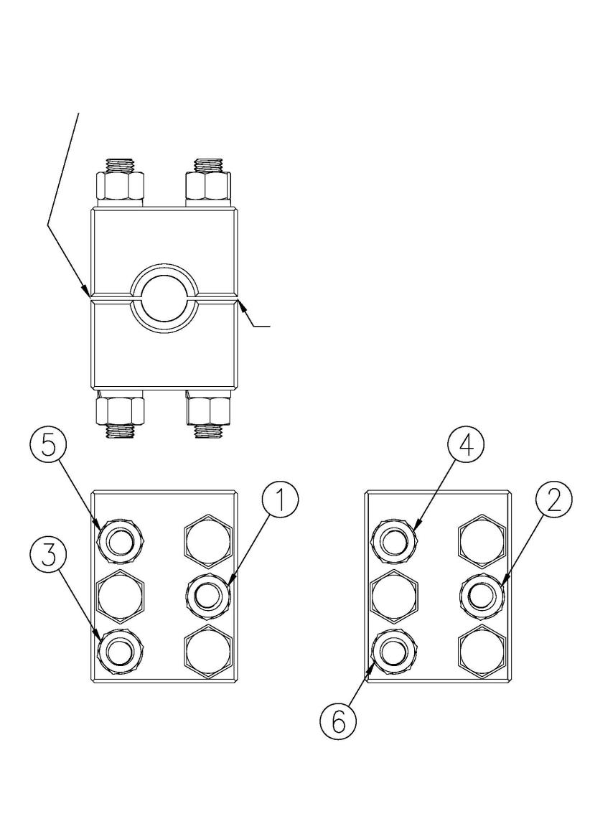

chink

chink

Do not try to install fixtures on the surface of any type of hard coated light rod —— Please consult the polishing rod manufacturer for technical assistance.

1. Thoroughly clean and remove any oil, grease or dirt from the light bar and the inside of the clip.

2. Bolts and nuts must be clean. Replace any bolt or nut with thread threads. Lubricate the threads with regular oil or grease for the best service life.

3. Slide the fixture onto the light rod / drive shaft. Hand tighten the nuts to ensure that the clearance between the clips is equal. Use the nuts and keep the clearance consistent to ensure the maximum carrying capacity of the light rod.

4. Tighten the nuts and bolts to 340 to 366 Nm (250 to 270 lb. ft) torque. A 1 / 8-inch socket wrench can be used. Torque wrench is highly recommended.

**3. Operation**

**3.1 Start the inspection**

Ensure that the ventilation cover and liquid level observation window are intact and damaged.

Check the level on the hydraulic tank using the level observation window.

Ensure that the polishing rod is clamped and properly seated with the drive shaft.

Point the motor start button to ensure the correct motor rotation direction. The inspection is done, and it can begin.

**3.2 Start**

Start the DQ 30 top drive and wait for the fluid to reach the surface. This requires the sealing device to establish the working pressure of the seal.

Gently tighten the seal adjustment cap until approximately 10-30 drops of fluid / min.

Use a grease gun, punch the full 10 shots of grease. For gas well dehydration (or wells with high moisture content), use Aqua Lube (from d.a . Stuart Company) —— This is a special grease (or similar domestic products) for high water content fluid formulation. This requires filling the entire sealing chamber with lubricant (about a small bag of grease coming out of the compression cap interface). The lubricating oil is pumped, and if the fluid seepage stops, the seal is ready.

If the fluid is still leaking, gently tighten the seal adjustment cap until the seepage stops. The packing rings are made of pure graphite and are therefore very soft, so they are completely sealed (very small compression) and the remaining packing is loose enough to carry the desired lubricant on its surface to ensure proper sealing.

**3.3 Reverse control**

DQ 30 top, drive with hydraulic braking system, connected to the drive shaft, to control the reverse speed. The hydraulic braking system always circulates oil when the top drive turns in the normal direction. The volume of this cycle is 0.45 cubic inches per turn. At the maximum speed of 600 rpm, the theoretical rate of the oil cycle is 2.34 gpm (gallon per minute, 8.85 l / min).

The pressure drop on the relief valve is minimal, so the thermal accumulation is negligible. The temperature of the hydraulic oil shall not be higher than 80°C (176°F). When the top drive is turned off, the system is recoil due to the energy stored in the pumping rod and the potential energy of the downhole fluid head. This recoil energy is released in a controlled manner, while the hydraulic pump delivers the fluid to a piston, pushing the brake pads to the brake disc attached to the shaft, producing friction that reduces the rotation rate. The hydraulic oil brake pressure can be controlled by a safety valve regulating the pressure of the system. Tighten the port hexagon nut (clockwise) to increase the brake pressure; otherwise (counterclockwise) to reduce the pressure level.(Factory pressure has been adjusted)

**The hydraulic schematic diagram of the brake system is as follows:**

|  |
| --- |
| **View # 3.3-1**  **DQ 30 hydraulic system schematic diagram** |

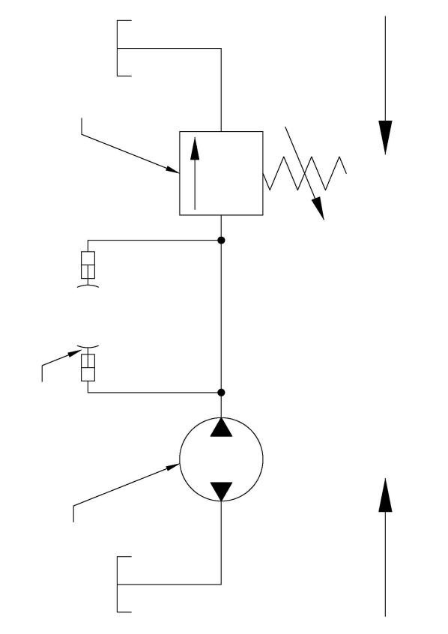

Brake flow direction

Normal flow

hydraulic pump

Split flow safety valve

brake block

**3.4 Stop and dismantling procedures**

Turn off the main power supply several secondary times and lock it

Let the drive recoil up to 0rpm

Make sure that all the well pressure has disappeared

Relax the packing function cover

Lift the pumping lever to release the stored residual torque

Remove the packing box bolts from the wellhead and lift the top drive unit evenly.

Clamp the light rod holder at the wellhead and place it at the wellhead, lower the crane, and remove the upper light rod holder

Lift the driver evenly and slide out of the pumping rod smoothly.

**4. Maintenance and lubrication**

**4.1 Routine**

**maintenance overhaul:**

Check the engine oil level

Check for the abnormal noise behavior

Check for seal leaks

Check temperature (max. 80 C, 80 F)

**Week check**

Check the oil leakage from the hydraulic tank, hydraulic pump and connector

Make sure that the oil is visible in the liquid-level observation window

Check the seal for leaks and grease and use the chart for reference as required

|  |  |  |  |  |  |
| --- | --- | --- | --- | --- | --- |
| The light rod speed rpm | **0-150** | **151-250** | **250-350** | **351-450** | **451-600** |
| Re-lubrication cycle | **7-14 days \*** | **For 6-12 days \*** | **For 5-10 days \*** | **4-8 Days \*** | **2-5 Days \*** |
| Lubricating oil quantity | **\*\*** | **\*\*** | **\*\*** | **\*\*** | **\*\*** |

Since each application is unique, experience will determine the optimal time interval, and therefore there is a series of re-lubrication intervals. A high frequency relubrication interval is recommended and can be gradually reduced before determining the optimal interval for the specific application. There is also an automated lubrication system —— contact the factory for details.

• • Apply enough grease to ensure the complete coverage of all packing rings. The —— should feel the resistance of the oil gun.

**monthly inspection**

Check the vent to ensure maintenance requirements

Reup the hydraulic tank if needed

**annual survey**

Once a year, the following preventive maintenance is recommended:

Replace the hydraulic tank oil

**4.2, lubricating oil**

The recommended oils and grease for the DQ 30 top drive are:

Hydraulic box: anti-wear, hydraulic oil-Chevron HD ISO 68 (or domestic corresponding oil)

Seal device: multi-purpose, extreme pressure, waterproof grease-Chevron black pearl EP2 (or domestic corresponding oil)

**4.3 Maintenance of sealing unit (see view 1.4-4)**

The sealing unit on DQ 30 top drive (Figure 1.4-4) uses rope packing as the sealing mechanism and consists of the following internal components (from bottom up):

The bottom is fitted with a grinding liner and a lip seal

The low packing gasket is loaded with one O-ring with two labial seals

Graphite packing ring with two sections 1 / 2 " square

A special on ring

Five sections 1 / 2 " square of the graphite packing ring

A sealing gasket

An upper packing ket with one O-ring

A packing pressure ring placed in the packing adjustment cap

Teefron packing for a light rod seal

An adjustable cover with packing (for compressed packing)

Note that the lubrication of the packing is critical to the successful sealing of the sealing unit see Section 4.1-General maintenance of the recommended lubrication intervals.

**5 Reference data**

**5.1 Formula**

**pressure:**

PSIx2.31= Foot of water head

**Torque and horsepower**

Torque (in pounds) =63025 hp / PM

Hp = torque (in) rpm / 63025

Hp = flow (gpm per minute) pressure (psi) / 1714 efficiency

**efficiency of pump:**

Volume efficiency = its actual capacity at the given velocity and the given depth / its capacity at the given velocity and zero head

Mechanical efficiency = hydraulic horsepower / brake horsepower

**matrixing**

1 barrel =42 gallons =0.159 m 3

1KW=0.746HP

1lbf=4.4482N

1ft.lb=1.355818N.M

**Dynamic load capacity of thrust bearing:**

10/3

L 1/ L 2=［C 2/ C 1］

**ad locum:**

L1 = Rated bearing life (see it on the nameplate) - - - - -25,000 hours @ 500 rpm

L2 = expected bearing life- - - - - - -hours xrpm

C1 = Rated bearing load (see nameplate) - - - - -60.9 kN (13,690 lbf)

C2 = New bearing load (based on expected bearing life)

For example, if you want to calculate the dynamic load capacity based on 17,500 hours (2 years) and 400 rpm:

3/10

C 2=C 1［L 1/L 2］

**3/10**

C 2=60.9KN ［25000hrs x500rpm /17500hrs x400rpm ］

C 2=72.47KN (16,303 Ibf )

For the sake of comparison, the Ca 90 of the thrust bearing is 115 kN (25,850 lbf). Similarly, as a reference, the equivalent ISO / AFBMA L10 dynamic load class is 443.6 kN (99,720 lbf).

**5.2. Maintenance and troubleshooting**

|  |  |  |
| --- | --- | --- |
| **question** | **omen** | **cause** |
| **The new equipment does not oil** | The drive shaft speed is correct and the torque indication is low | 1 . The pump rod is broken  2. Tubing and / or stator release  3. The rotor is broken  4. Unconstraint of rotor and stator (pump) |
| Drive shaft speed is normal and the torque indication is high | 1 . Oil pipe leakage  2. Plugging caused by the damage of the pumping rod  3. Motor damage  4. Motor mismatch (wrong motor selection) |
| The drive shaft does not rotate, the motor shaft rotates at the correct speed, and the drive belt escapes from the drive | 1. Blocking gging caused by damaged pumping rod connection  2. Pump into sand  3. Overheat the well  4. Garbage / metal is squeezed between the rotor and the stator.  5. The pump rotor and stator are stuck  6. Kill the bearing box |
| Drive shaft not rotating-the motor speed is low when the belt is removed from the top drive. | 1 . The working motor winding is damaged.  2. Incorrect motor selection. |
| **No flow rate of the existing equipment (no oil output)** | No oil output, the drive shaft speed is normal, and the torque display is lower than normal | 1 . Overdue wear of the working rotor and / or stator  2 . Stator and / or tubing release  3. sour rot causes the peeling of the rotor chrome layer  4. Damextraction rod  5. Damaged rotor |
| No oil output, drive shaft speed is below normal, torque shows higher than normal | 1 . Stator elastomers are "extruded" due to chemical corrosion or excessive temperature.  2. Motor damage  3. Incorrect motor (if the motor is replaced) |
| The spindle does not turn- - - - -motor shaft rotates normally, the drive belt out from the drive | 1. Chemical corrosion causes the stator expansion  2. Pump into sand  3. Overheat the well  4. Kill the bearing box |
| **Newly installed equipment with a low flow rate** | The flow rate is uniform but lower than expected; the torque indication is normal | 1 . Working raw flow is not calculated correctly, or uses incorrect data.  2. The pump is blocked after inhaling mud, rock, etc.  3. High vapor-liquid ratio (high gas ratio)  4. Incorrect rotor / stator clearance  5. Pipe perforation |
| Flow is lower than expected and torque indicates above normal | 1. Incorrect selection of transmission belt and transmission wheel  2. Low voltage  3. Excessive torque due to incorrect rotor / stator size. |

|  |  |  |
| --- | --- | --- |
| question | omen | cause |
| Low-flow rate of the existing equipment | The flow rate is uniform but below normal; the torque display is normal. | 1 . Working rotor and / or stator are worn out  2. Sand goes into the well chamber to limit the flow into the pump  3. Pipe wall perforation |
| Flow is lower than normal flow; torque indicates higher than normal | 1. Low line voltage  2. Too much sand causes high torque  3. The stator is chemically corroded |
| Pulating or uneven flow on the new device | Flow pulsation or unbalanced-torque shows normal (possibly unstable). | 1 . The working gas-to-liquid ratio is too high  2. Too much silt or sand, resulting in fluid fluctuations  3 . The vacuum degree on the casing is too high  4. The hydraulic pump compensator is set up too low |
| Flow pulsating or uneven-torque is shown above normal | 1. Transator friction  2. Excessive silt or sand, leading to fluctuations in the fluid flow  3. Incorrect ratio of the motor and / or belt wheel |
| Pulating or uneven flow on existing devices | Flow pulsation or unbalanced-torque display normal (possibly unstable) | 1. Well liquid level has been pumped low  2. Excessive silt or sand, leading to fluctuations in the fluid flow  3. The air-to-liquid ratio is too high  4. Excessive vacuum on the casing |
| Flow pulsating or uneven-torque displayed above normal. | 1 Excessive silt or sand, causing fluctuations in the flow rate.  2. Stator damage- -fracturing or motion cut  3 Motor incorrect (if motor just replaced)  4. The stator expansion caused by chemical corrosion or temperature |

**Maintenance and service log**

|  |  |  |
| --- | --- | --- |
| **date** | **Execute maintenance** | **remarks** |
|  |  |  |
|  |  |  |
|  |  |  |
|  |  |  |
|  |  |  |
|  |  |  |
|  |  |  |
|  |  |  |
|  |  |  |
|  |  |  |
|  |  |  |
|  |  |  |
|  |  |  |
|  |  |  |
|  |  |  |
|  |  |  |
|  |  |  |
|  |  |  |
|  |  |  |
|  |  |  |
|  |  |  |
|  |  |  |
|  |  |  |
|  |  |  |
|  |  |  |